**AZURE MACHINE LEARNING SERVICES**

Contents

**AZURE MACHINE LEARNING SERVICES** 3

Azure Machine Learning Services Architecture 3

Your Azure Portal for the duration of this class 3

SDK Documentation 3

Using your own Jupyter Notebook Services 4

Data Preparation 4

Model Training 5

Model Deployment 5

Model Monitoring 5

Machine Learning Pipelines 5

# **AZURE MACHINE LEARNING SERVICES**

<https://docs.microsoft.com/en-us/azure/machine-learning/service/>

## Azure Machine Learning Services Architecture

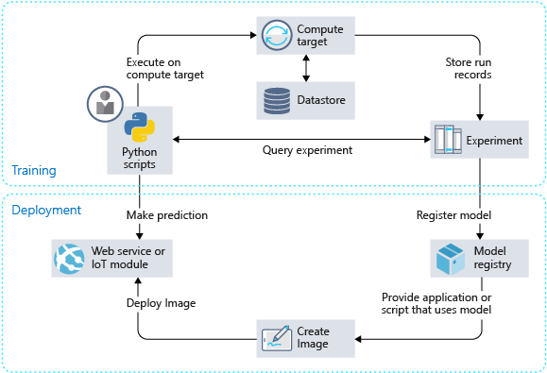

* <https://docs.microsoft.com/en-us/azure/machine-learning/service/concept-azure-machine-learning-architecture>

## Your Azure Portal for the duration of this class

* <https://portal.azure.com/#@divergenceone.onmicrosoft.com>
* az account set --subscription 3c3bb71f-3a4c-436f-9e0a-7407d75a82fa

## SDK Documentation

* <https://docs.microsoft.com/en-us/python/api/overview/azure/ml/intro?view=azure-ml-py>

## Using your own Jupyter Notebook Services

* <https://docs.microsoft.com/en-us/azure/machine-learning/service/samples-notebooks>
* Install Conda Environment

1. Download and install 64-bit Python 3.7 from <https://docs.conda.io/en/latest/miniconda.html>
2. Open Anaconda Prompt to run the following commands:

|  |  |
| --- | --- |
| conda create -n enterpriseml python=3.6 | Create an environment named enterpriseml with Python 3.6 |
| conda activate enterpriseml | Activate the environment created in Step #1. You will see the environment |
| conda info –envs | List the all the environments configured on your computer |
| conda install tensorflow | Install Tensorflow into the eml01 environment |
| pip install azureml-sdk[notebooks] | Pip is a universal installer that you can use when packages are available on conda. |
| pip install azureml-sdk[automl] |  |
| pip install azureml-sdk[databricks] |  |
| pip install azureml-dataprep |  |
| conda deactivate | Run this command when you re done with experimentation or want to bring up another environment |
| conda env remove --name enterpriseml | Remove the environment completely from the system |

* **Tutorial**: <https://docs.microsoft.com/en-us/azure/machine-learning/service/quickstart-get-started>

## Data Preparation

* <https://docs.microsoft.com/en-us/azure/machine-learning/service/tutorial-data-prep>

## Model Training

* **Auto Train**: <https://docs.microsoft.com/en-us/azure/machine-learning/service/tutorial-auto-train-models>
* **Tutorial**: <https://docs.microsoft.com/en-us/azure/machine-learning/service/tutorial-train-models-with-aml>

## Model Deployment

* <https://docs.microsoft.com/en-us/azure/machine-learning/service/tutorial-deploy-models-with-aml>
* **Tutorial**: <https://docs.microsoft.com/en-us/azure/machine-learning/service/tutorial-deploy-models-with-aml>

## Model Monitoring

* **Enable Data Collection from Models**: <https://docs.microsoft.com/en-us/azure/machine-learning/service/how-to-enable-data-collection>
* **Enable App Insights in Production**: <https://docs.microsoft.com/en-us/azure/machine-learning/service/how-to-enable-app-insights>

## Machine Learning Pipelines

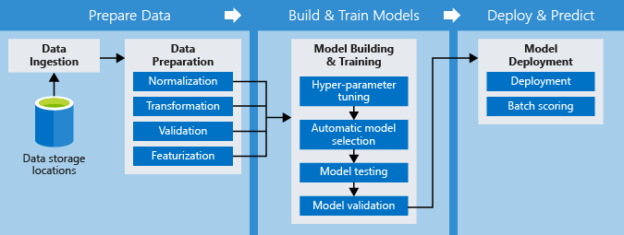

* <https://docs.microsoft.com/en-us/azure/machine-learning/service/concept-ml-pipelines>